DBMS ASSIGNMENT 1

ARJUN KUNCHAM

1602-21-737-010

Topic: Techie quiz for c and python

ABSTRACT

This techie quiz is designed to test your knowledge of programming in C and Python. The quiz includes questions that cover a range of topics, from basic syntax and data types to more advanced concepts like control structures and functions.In the C section of the quiz, you will be asked to write code snippets and predict their output. These questions will test your understanding of C syntax and your ability to reason about the behaviour of C programs.In the Python section of the quiz, you will be asked to answer questions about Python data types, functions, and control structures. These questions will test your knowledge of Python syntax and your ability to write and read Python code.

REQUIREMENTS

1. 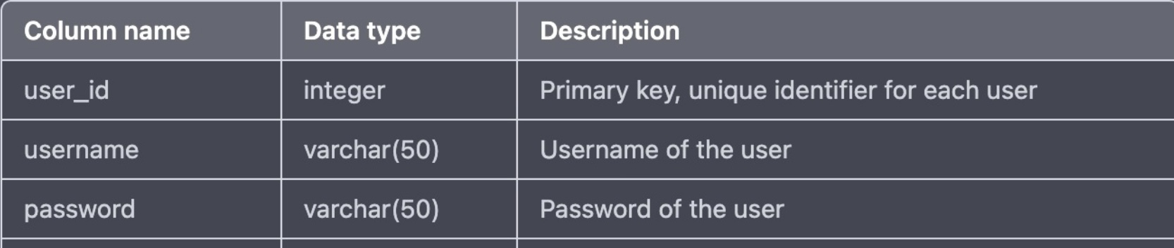User table

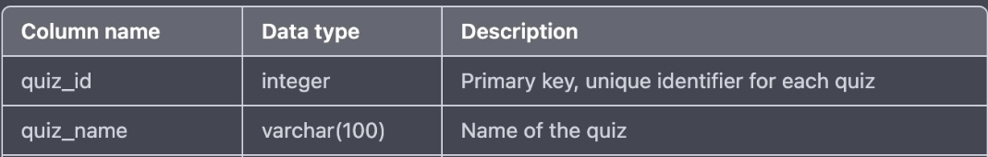2.QUIZ TABLE

3.QUESTION TABLE

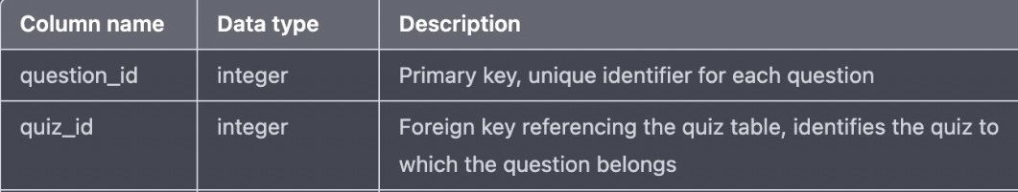



4.SCORE TABLE

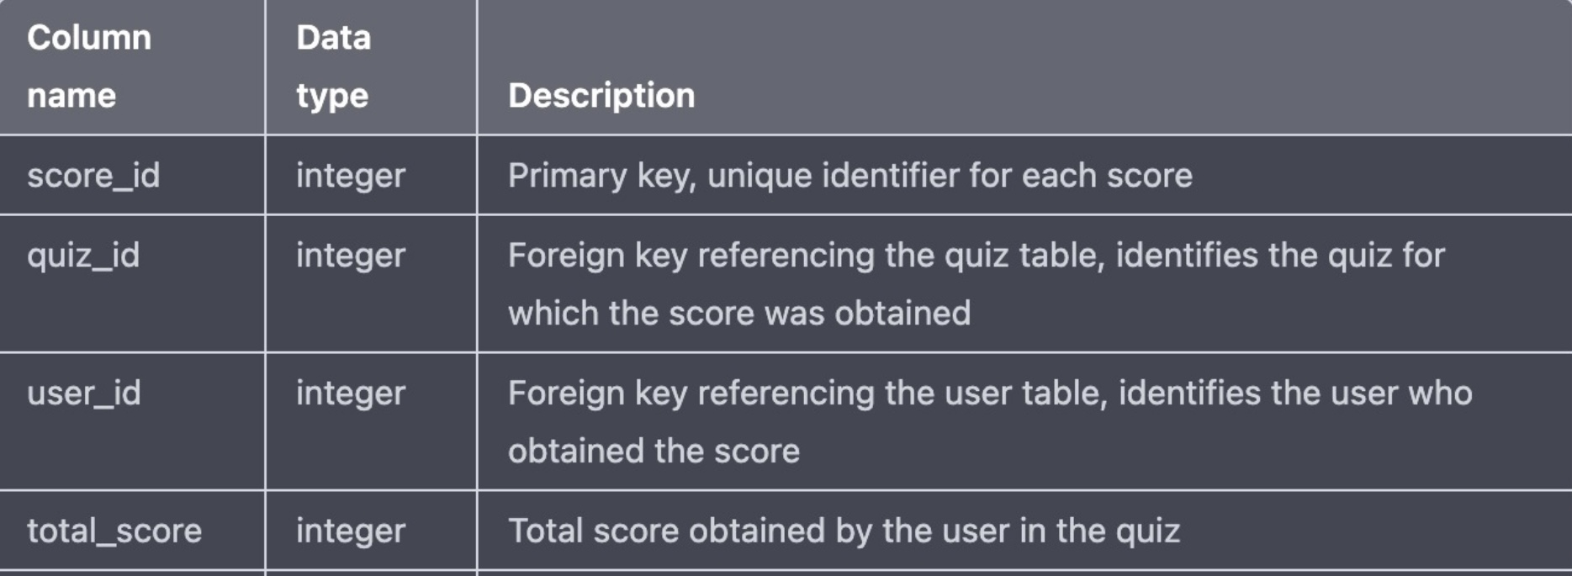

ER DIAGRAM

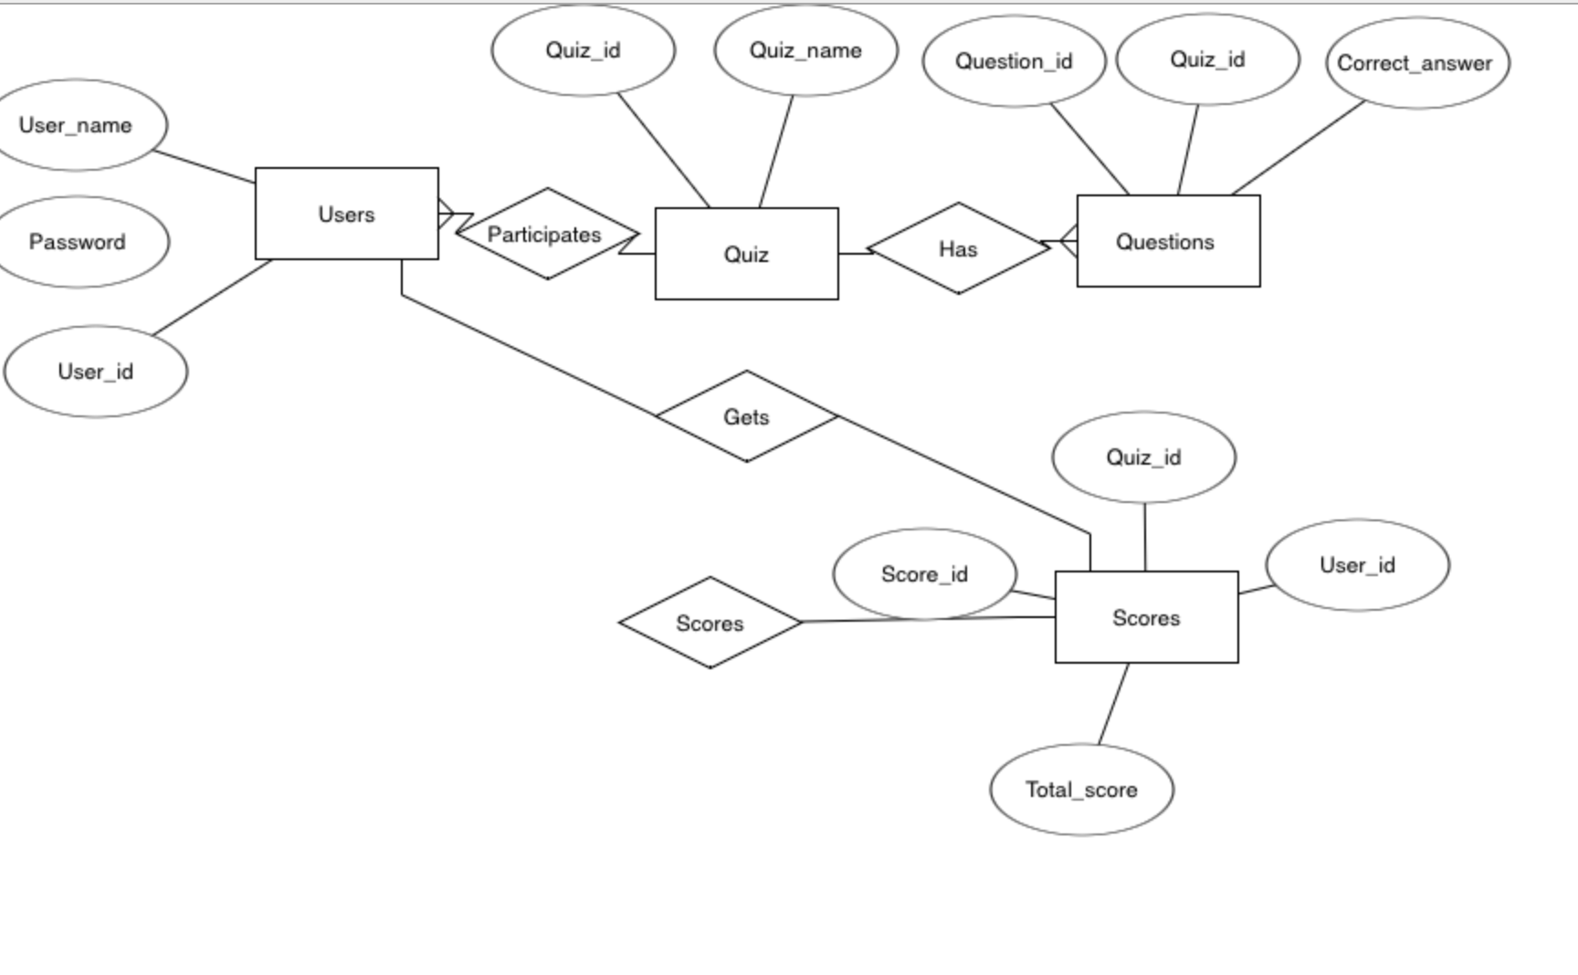

DDL COMMANDS:

1.creating a table for users

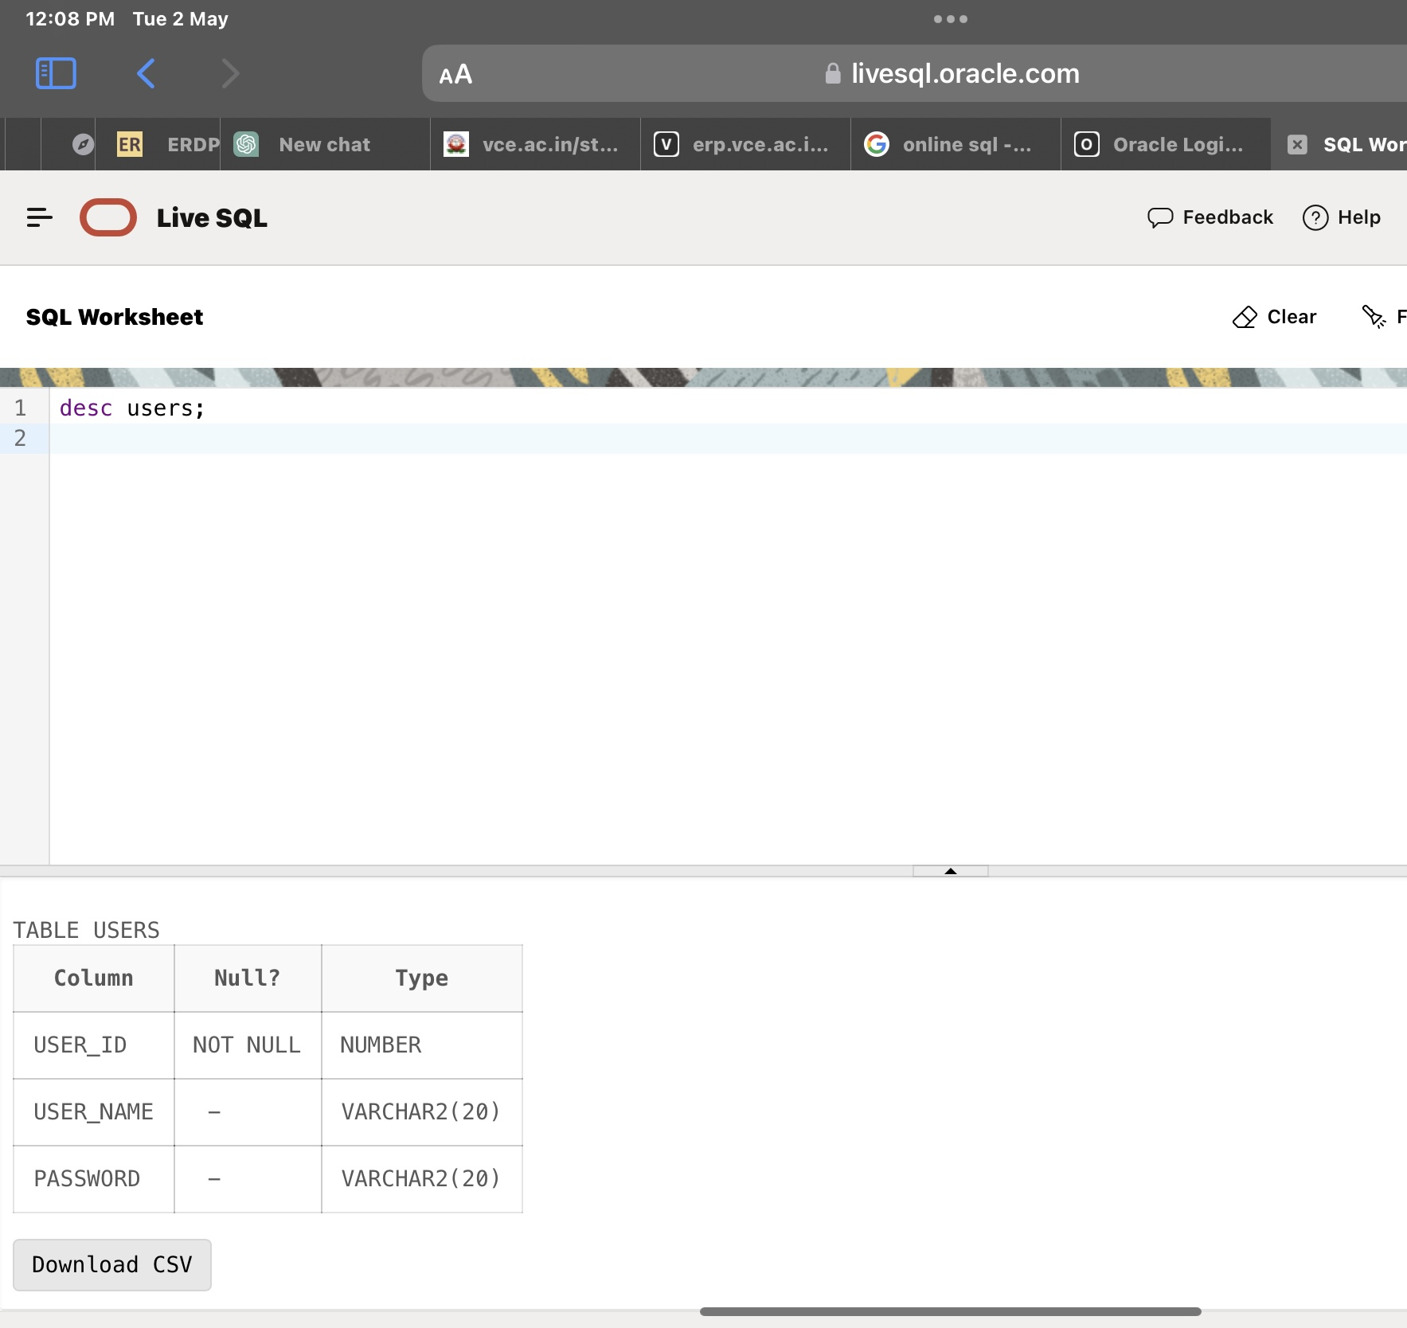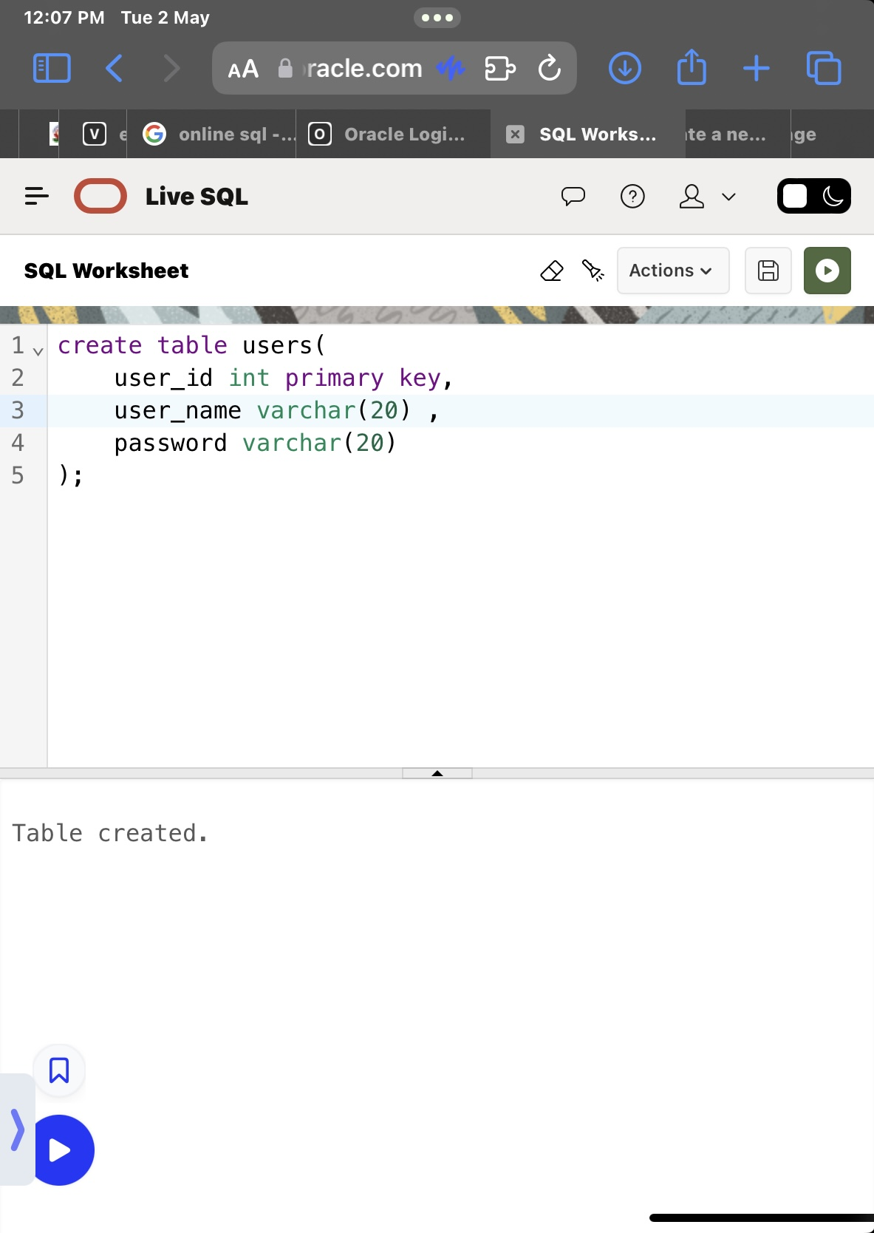

2.creating a table for quiz

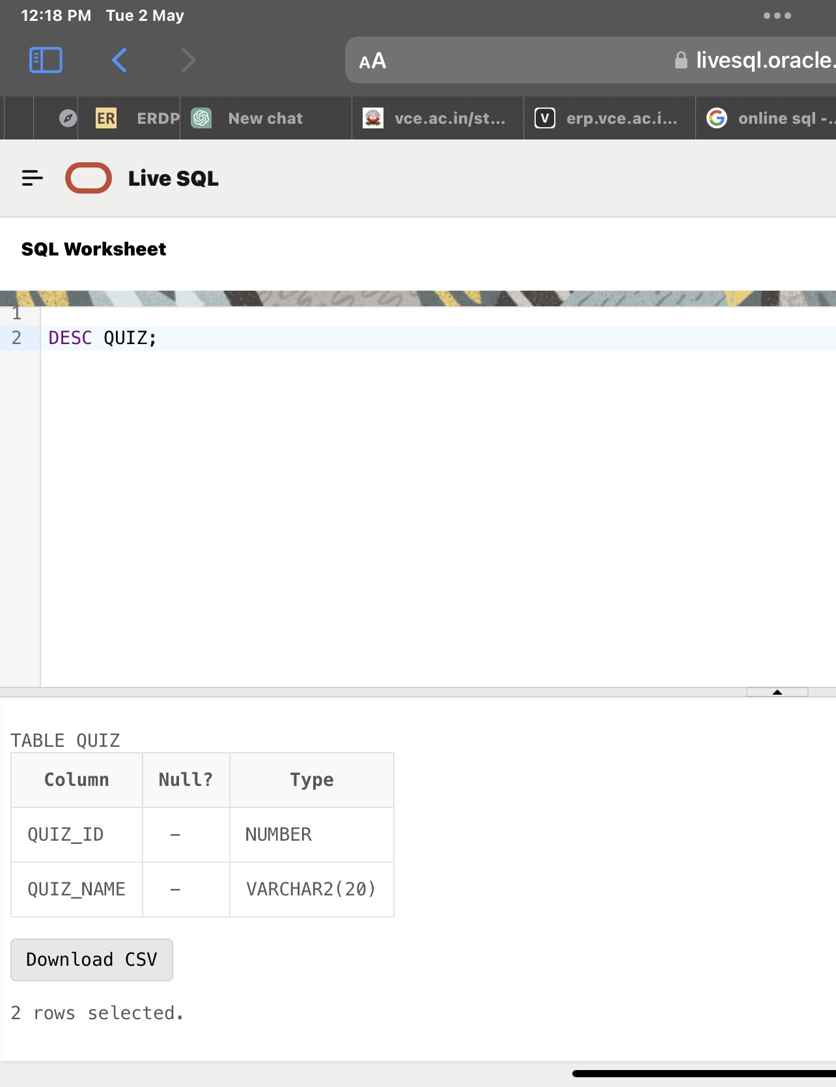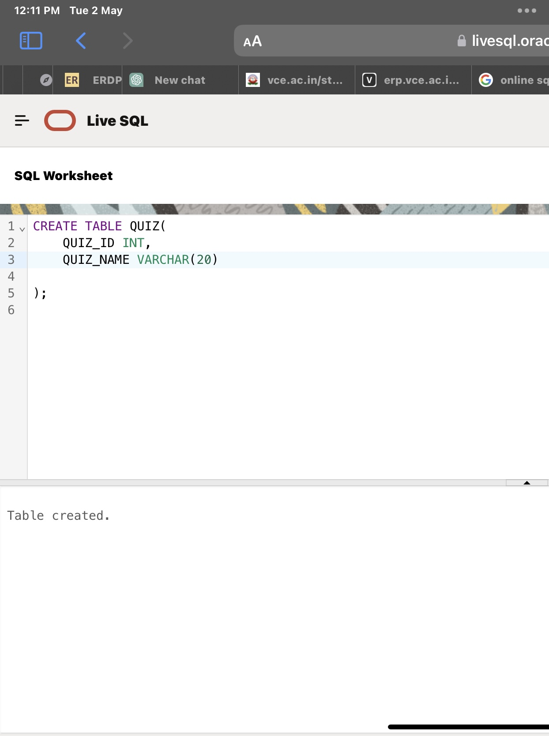

3.creating a table for question

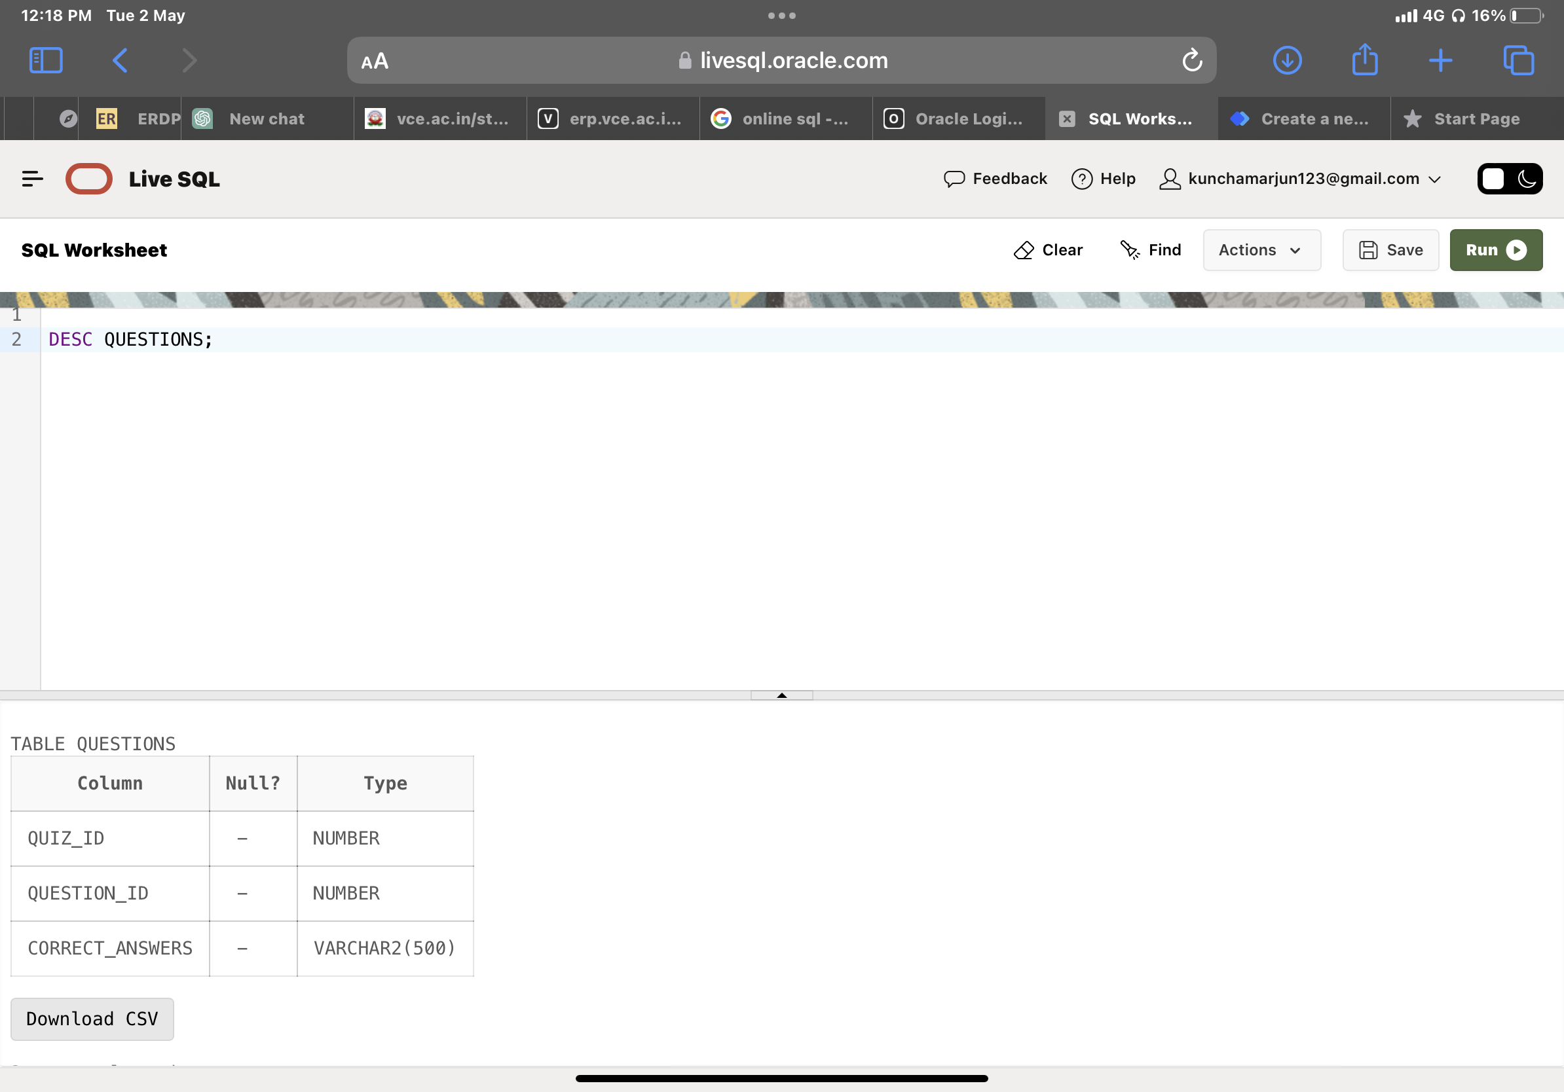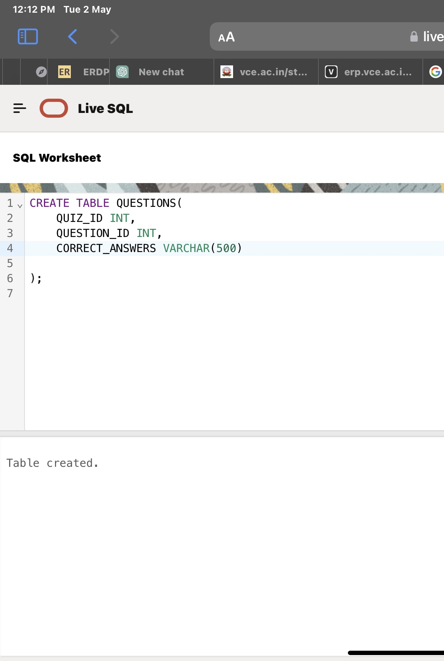

4.creating a table for score

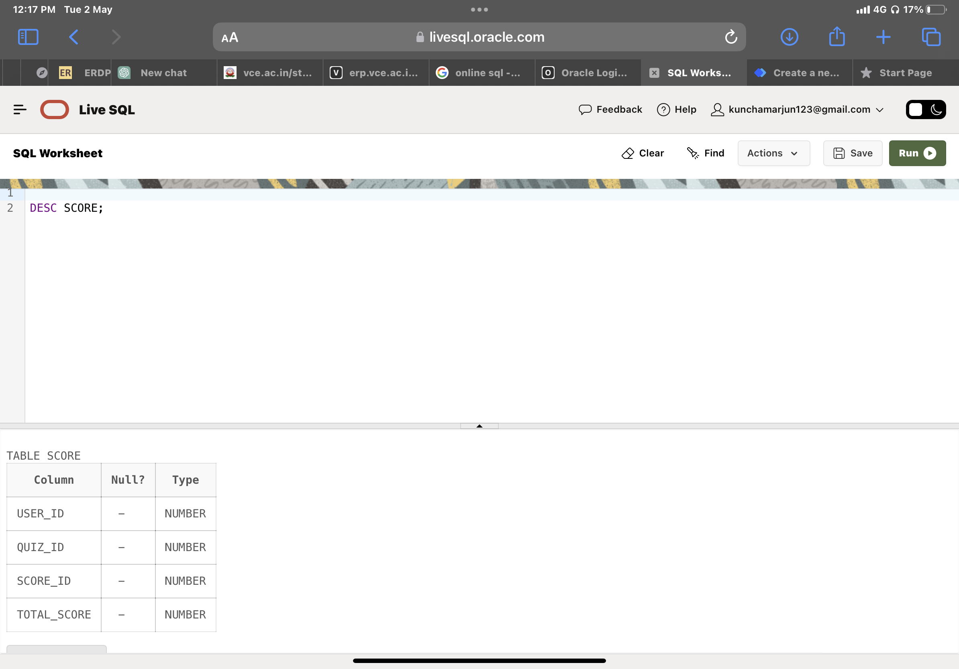

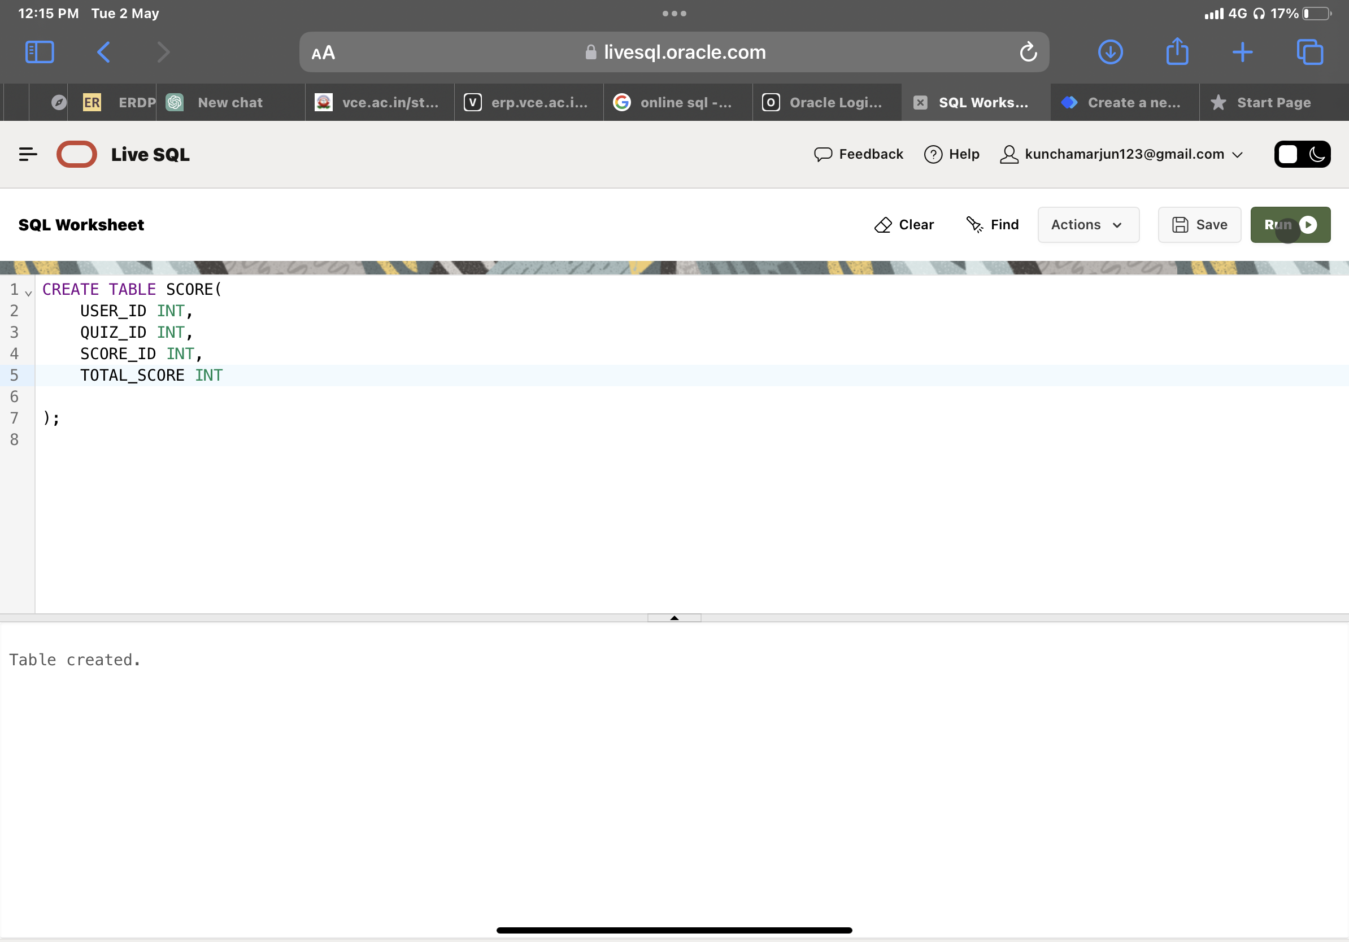

DML COMMANDS:

1.Inserting Into user

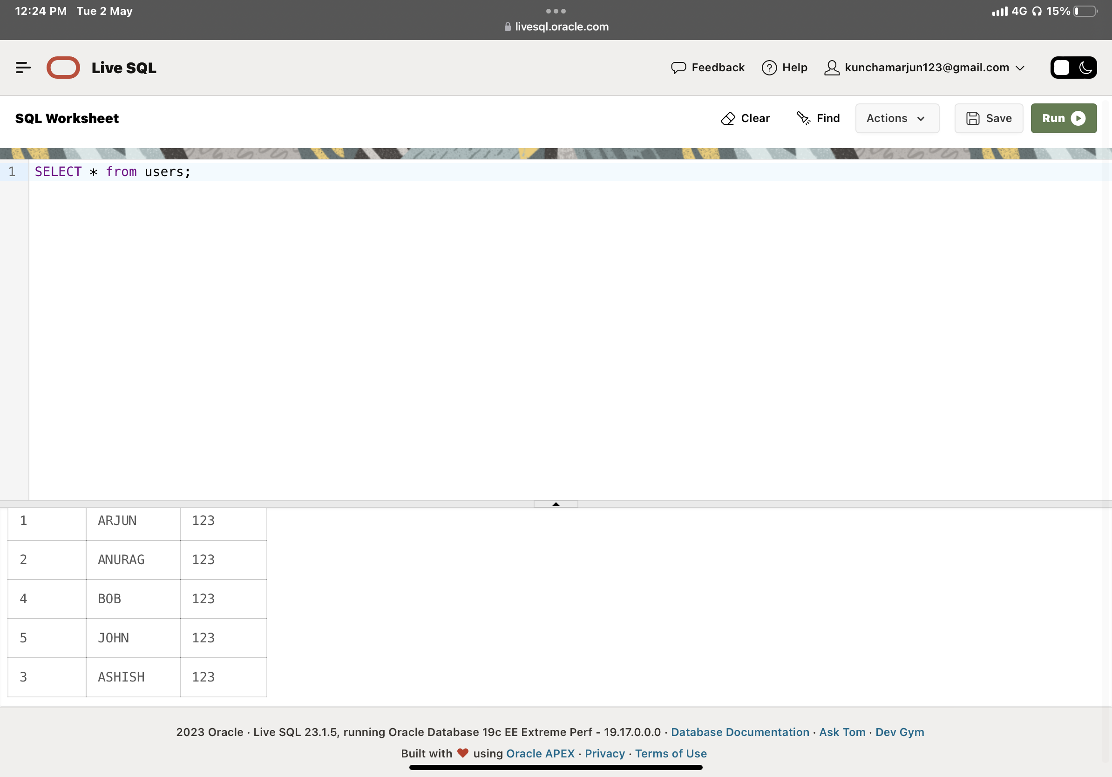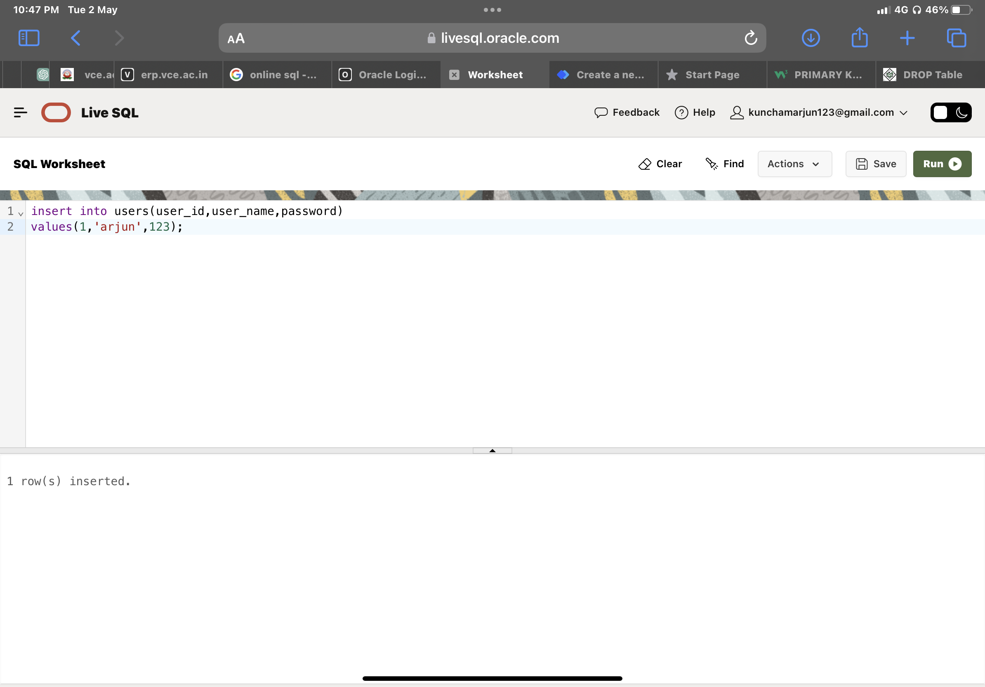

2.Inserting Into Quiz

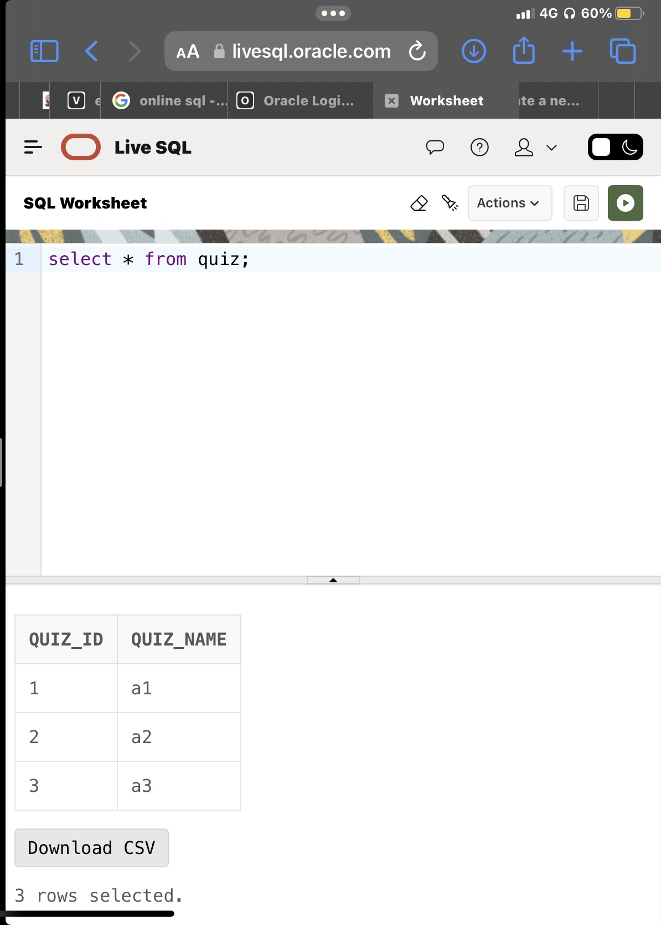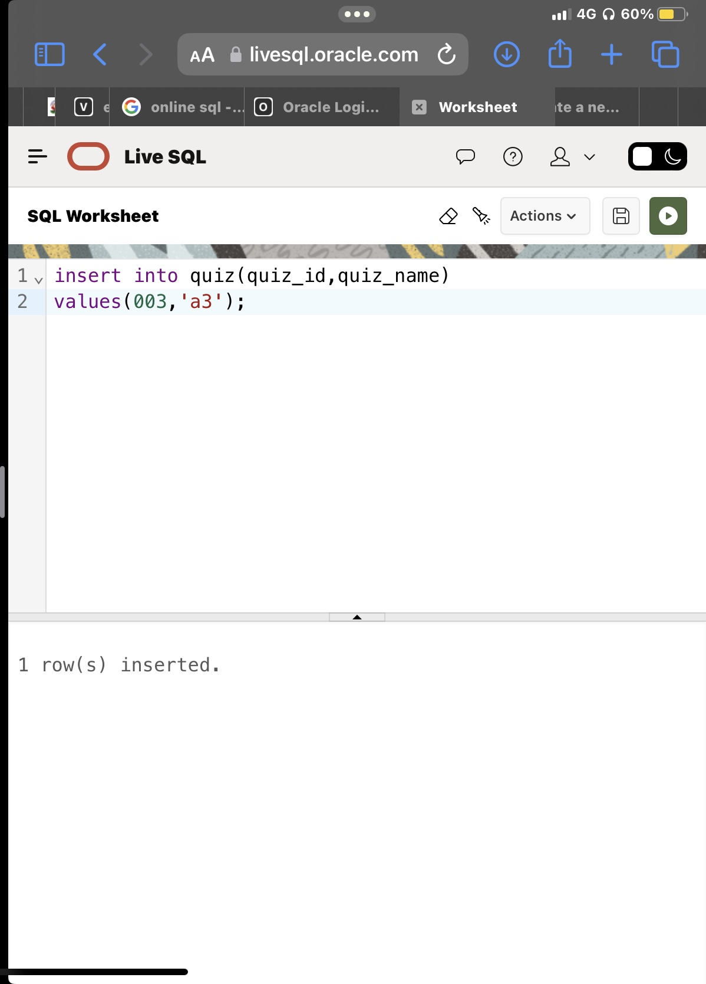

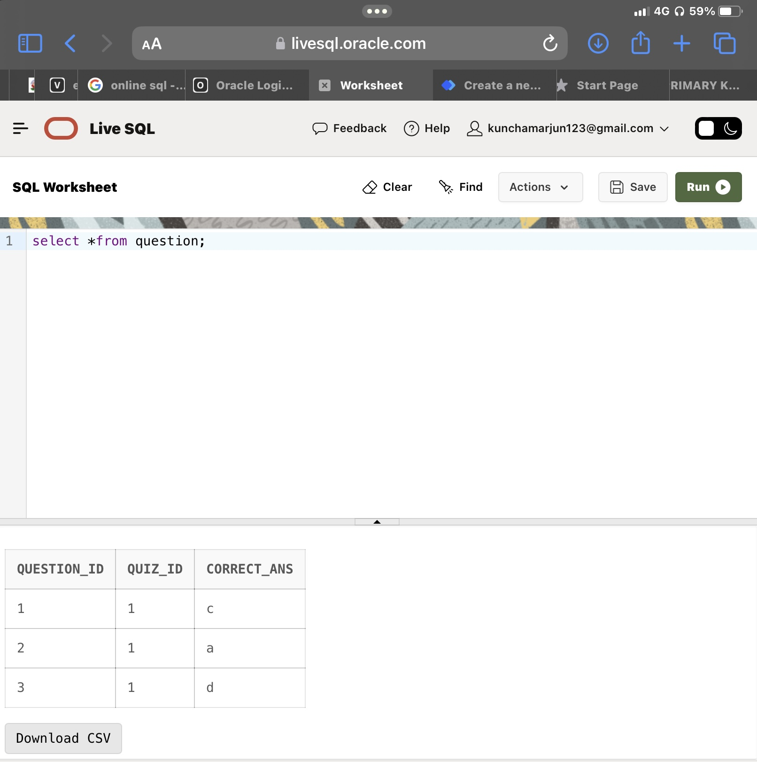3.Inserting into questions

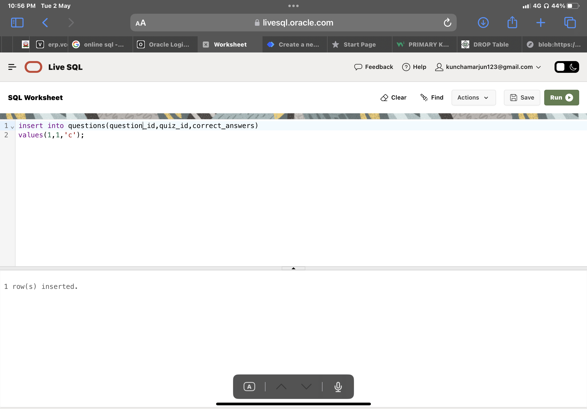

4.Inserting into score

